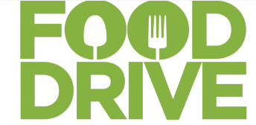  HELP US FIGHT HUNGER IN OUR COMMUNITY.  When:  ENTER DATE HERE  ENTER TIME HERE  Where:  LOCATION INFO HERE  AND ANY ADDITIONAL LOCATION DETAILS HERE  TO BENEFIT:  ENTER THE FOOD SHELF THAT WILL BENEFIT HERE  fOR MORE INFORMATION:  Enter your contact info or web address here | Sugguested food drive items:  Canned or dry beans  Canned fish or meat  Canned vegetables,  Canned fruits  Canned soups & chili  Peanut butter  Grains  Boxed meals: mac&cheese, hamburger helper etc.  Hot or cold cereal  100% juice: incl. juice boxes  Healthy snacks  Paper towels & toilet paper  Dish soap & sponges  Toiletries of any kind, including feminine products

