Hunger in America 2014
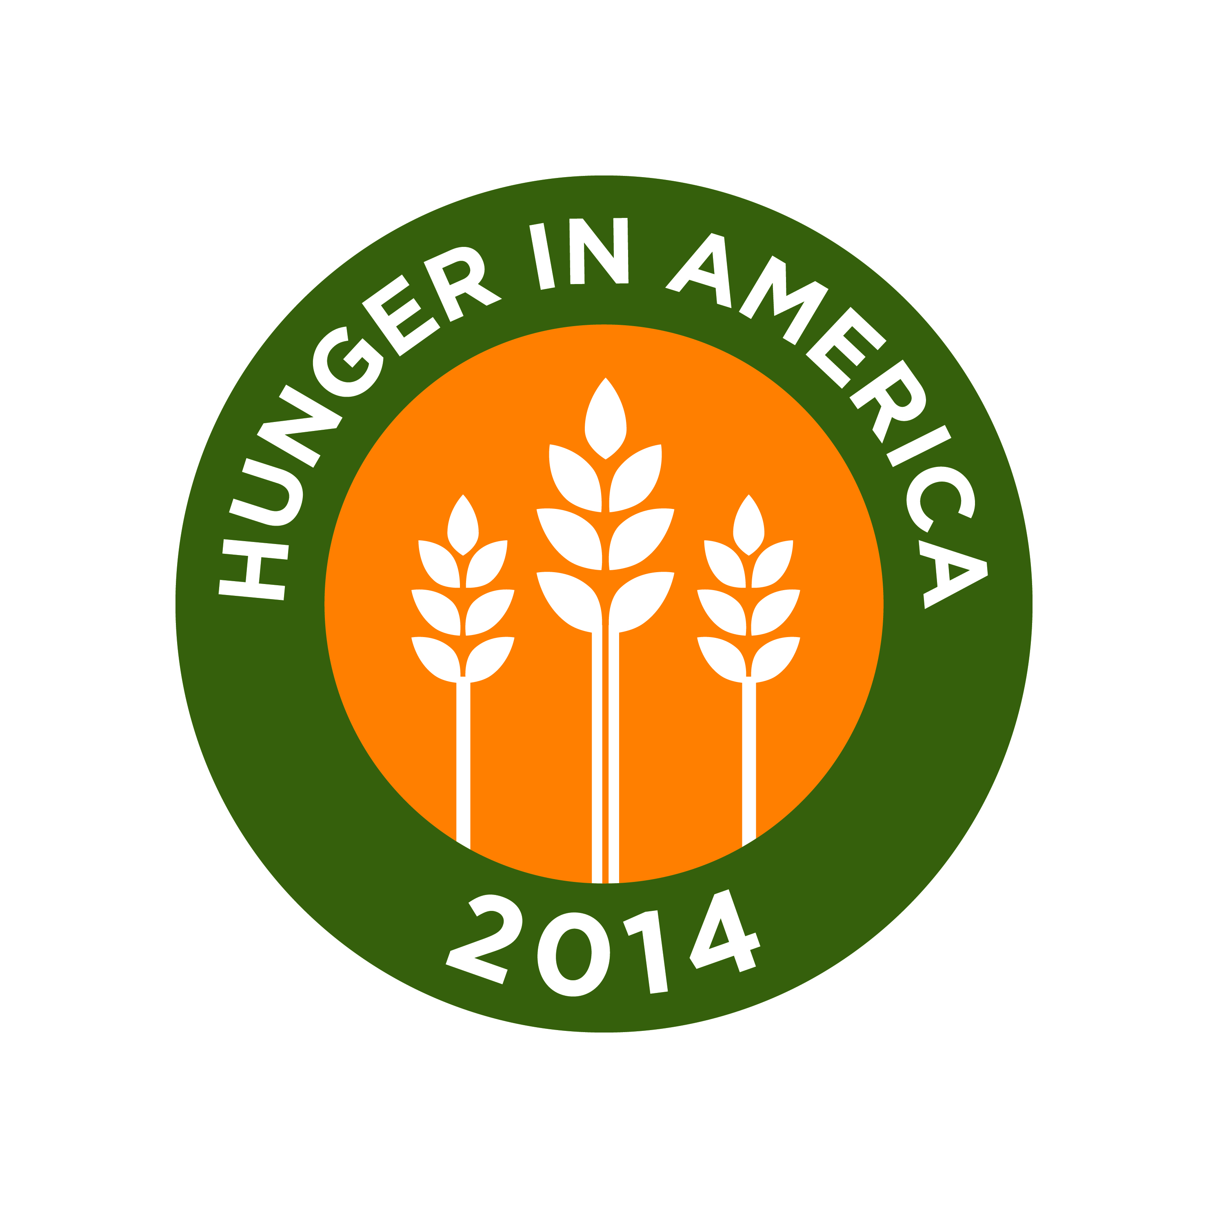

Volunteer Availability Information

Volunteer Name:

The Hunger in America 2014 Client Survey will take place from April 2013 through August 2013. Please specify your availability to volunteer during the client data collection period by completing Table A or Table B below.
- Complete Table A if you are available during the same hours on the same day(s) of the week.
- Complete Table B if your availability changes during the client survey data collection period.
In addition,
- Complete Table C to specify if there are specific periods of time that you are not available to volunteer.
- Complete Table D to add general comments about your availability.
Table A. Complete this table if you are available during the same hours on same day(s) of the week.
Day of Week | Hours Available
Sunday
Monday
Tuesday
Wednesday
Thursday
Friday
Saturday

Table B. Complete this table if the days/hours you are available changes over time (e.g., from month to month). For example, if you are available from 9am to 2pm on Sundays between April 15 and May 30 but it changes to 12pm to 4pm between June 1 and June30, indicate April 15 as the ‘from period’ and May 30 as the ‘to period’ in the first column and specify the hours for Sunday. Then in the next column indicated June 1 as the ‘from period’ and June 30 as the ‘to period’ and specify the hours for Sunday.
 | Hours Available During Each Time Period
Time Period | From:__________  To:____________ | From:__________  To:____________ | From:__________  To:____________ | From:__________  To:____________ | From:__________  To:____________ | From:__________  To:____________
Day of the Week
Sunday
Monday
Tuesday
Wednesday
Thursday
Friday
Saturday

Table C. Complete this table if there are specific periods of times that you are not available.
Period of Unavailability | Brief Summary/Comments

Table D. Please add any general comments about your availability.

