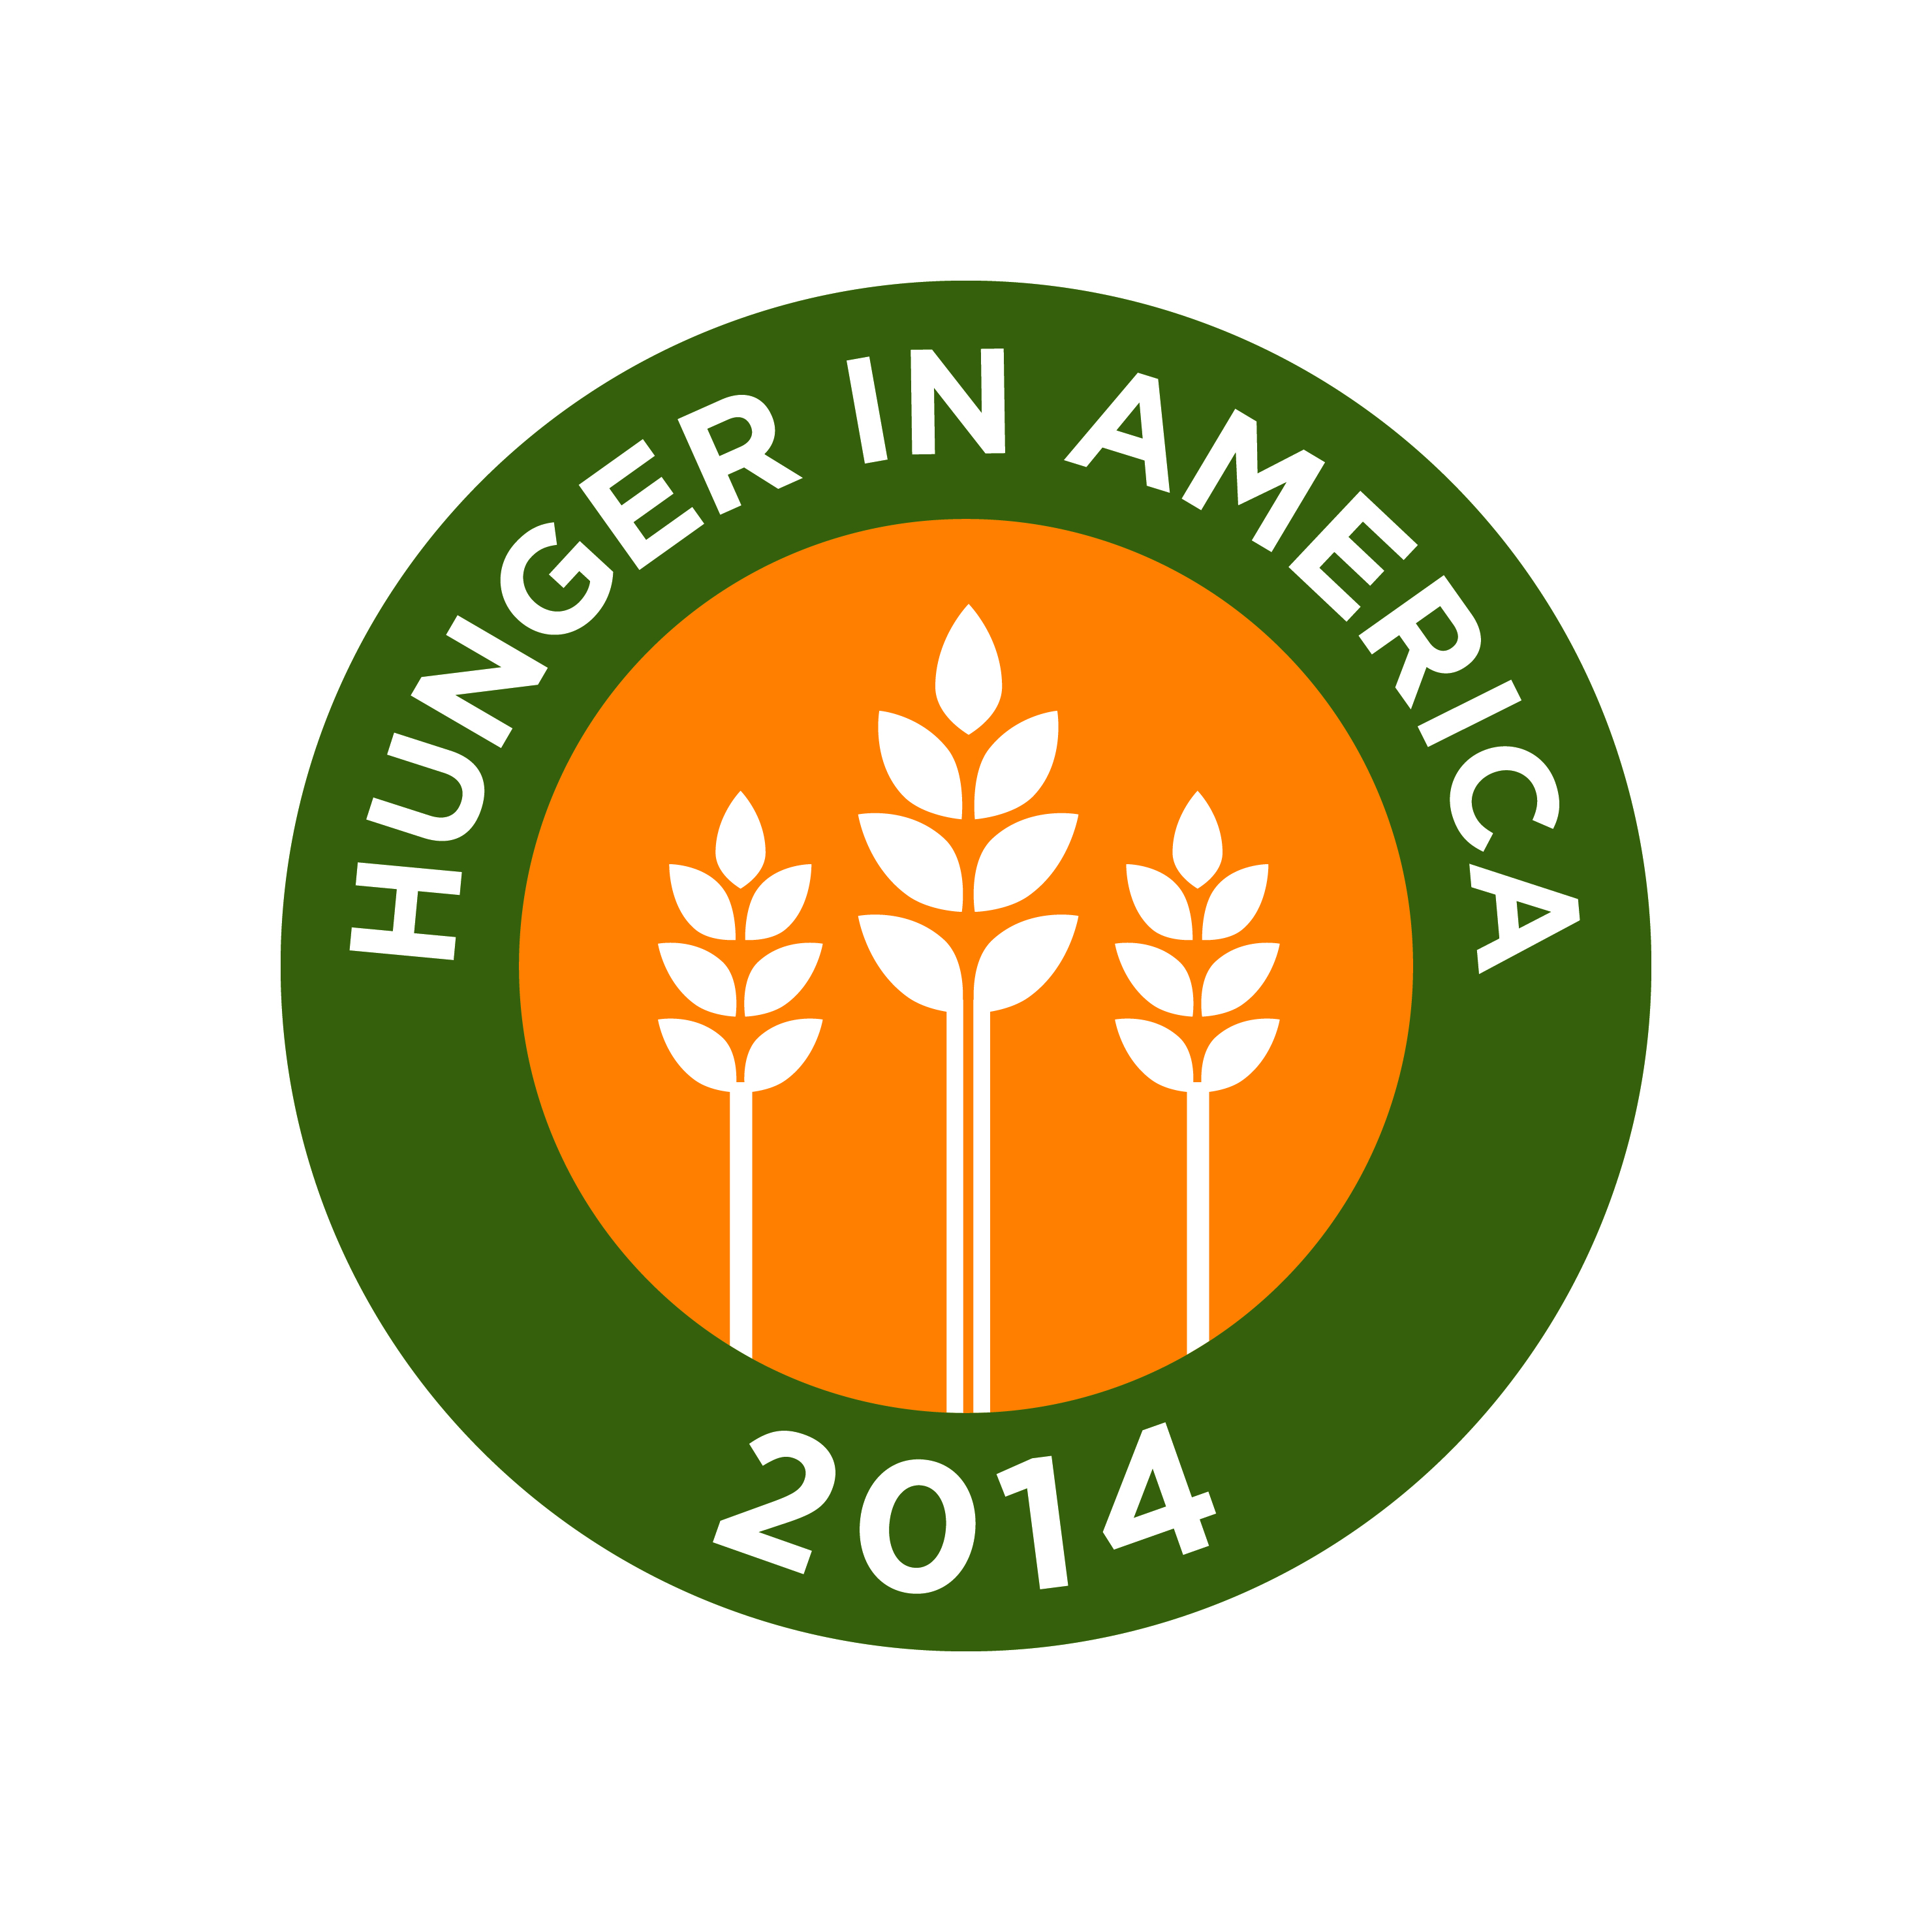

Hunger in America 2014

Volunteer Information Form

Contact Information
Name
Street Address
City ST ZIP Code
Primary Phone | Type (circle one): Home Cell Work
Secondary Phone | Type (circle one): Home Cell Work
E-Mail Address

Availability
When are you available to start: _____/______/__________ (month/day/year)
How long are you available (end date): _____/______/__________ (month/day/year)
Specify the days and hours you are available for volunteer assignments on the attached worksheet:

Languages
In which of the following languages are you fluent? (First, check all languages that apply. Second circle the type of fluency you have in that language)
Language | Type
English | Speak Read Write
Spanish | Speak Read Write
Chinese | Speak Read Write
[Insert Language] | Speak Read Write

Special Skills or Qualifications
Summarize special skills and qualifications (e.g., communication skills, computer skills, experience working with diverse populations, etc.) you have acquired from employment, previous volunteer work, or through other activities, such as hobbies or extracurricular activities.

Previous Volunteer Experience
Do you have previous volunteer experience? YES NO
Do you have volunteer experience in a previous Hunger Study? YES NO
If you have previous volunteer experience, please summarize below.

How did you hear about this volunteer position?

Person to Notify in Case of Emergency
Name
Street Address
City ST ZIP Code
Primary Phone | Type (circle one): Home Cell Work
Secondary Phone | Type (circle one): Home Cell Work
E-Mail Address

Agreement and Signature
By submitting this volunteer information form, I affirm that the facts set forth in it are true and complete. I understand that if I am accepted as a volunteer, any false statements, omissions, or other misrepresentations made by me on this application may result in my immediate dismissal.
Print Name
Signature
Date

Our Policy
It is the policy of this organization to provide equal opportunities without regard to race, color, religion, national origin, gender, sexual preference, age, or disability.

Thank you for completing this volunteer information form and for your interest in volunteering with the Hunger in America 2014 Study.

